An Explainable Action-Token Generation Framework Based on Bladder Ultrasound Segmentation and Image Quality Assessment
Seong Jeong^{1,2,3}, Minsung Kim^{2,3,4}, Dongho Yee^{2,3,4}, Yechan Seo^{1,2,3}, Juahn Oh^{1,2,5}, Hyoun-Joong Kong^{1,5,6,*}
¹ Department of Medicine, Seoul National University, Seoul, Republic of Korea
² Department of Transdisciplinary Medicine, Seoul National University Hospital, Seoul, Republic of Korea
³ Rosota Inc., Seoul, Republic of Korea
⁴ Department of Mechanical Engineering, Seoul National University, Seoul, Republic of Korea
⁵ Eulji University College of Medicine, Daejeon, Republic of Korea
⁶ ICMIT, Seoul National University Hospital, Seoul, Republic of Korea
*Corresponding Author

Abstract: During morcellation in holmium laser enucleation of the prostate (HoLEP), a suprapubic probe must stay over the bladder lumen; automating that view needs an explicit, auditable representation of image state, which a mask alone is not. We convert segmentation and image-quality assessment into a safety-constrained, machine-readable action token: a U-Net segments the lumen, a transparent quality function Q summarises the frame, and a discrete action state, one of move-left, move-right, hold, or check-filling, is paired with a continuous lateral displacement ê. The vocabulary is bounded by what Q distinguishes: against frame-to-frame jitter its attained range [0.14, 0.78] separates 47 distinguishable states. Both boundaries are derived, not tuned: an anechoicity gate assigns check-filling and an uncertainty deadband assigns hold below 1.64σ = 8.1 px of centroid noise, σ = 4.92 px. On 1,936 laterally translated held-out frames the action state is 85.2% correct with 0.10% direction error and displacement follows slope 0.993; graded magnitude classes drop accuracy to 76.5% and 70.7%. The token layer targets HoLEP probe guidance; closed-loop validation remains future work.
Keywords: bladder ultrasound segmentation, image quality assessment, explainable artificial intelligence, action token, robotic probe control, HoLEP morcellation

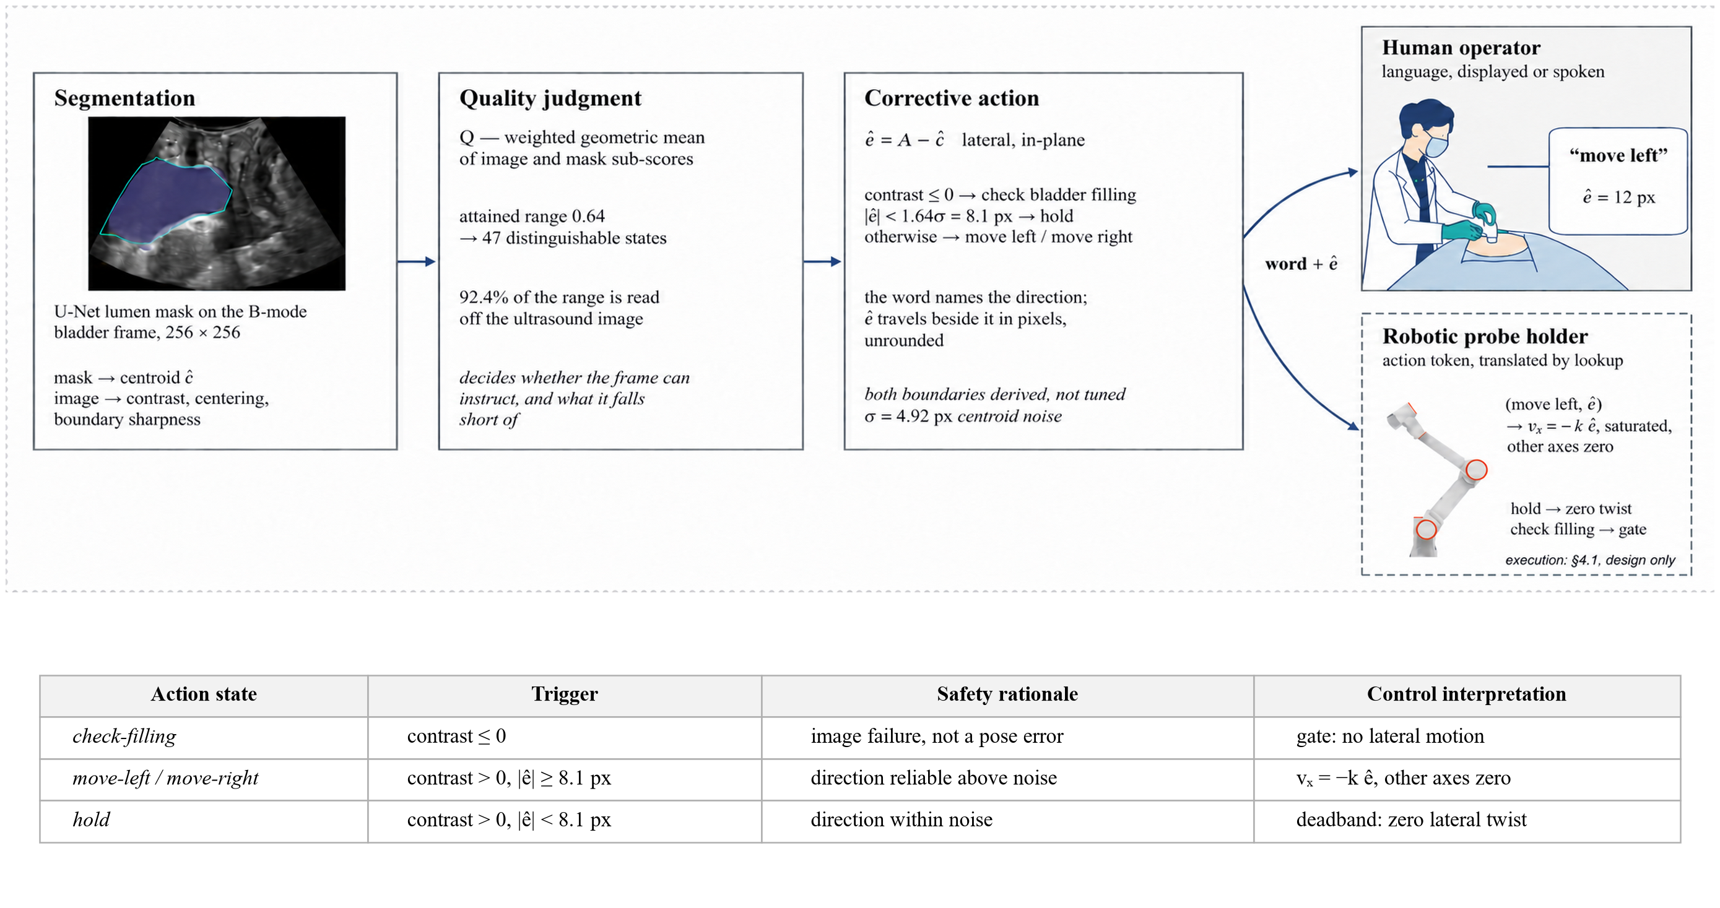
Figure 1. The action-token generation framework and its four action states. An ultrasound frame is segmented (U-Net), summarised by the image-quality function Q, and emitted as a structured token (a, ê, Q) decoded by a fixed downstream rule (top). The table lists each state's trigger, safety rationale, and deterministic interpretation; the dashed downstream execution is a potential future integration, not validated.

I. Introduction
During the morcellation phase of holmium laser enucleation of the prostate (HoLEP), a suprapubic ultrasound probe must be kept over the bladder lumen [1]. Deep networks segment the bladder accurately [3, 4] and guidance systems steer toward a standard view [5], but a segmentation mask is not directly usable by a downstream controller, and end-to-end control hides why a motion is issued and is hard to audit under segmentation uncertainty. We insert an explainable, safety-constrained layer that turns image-derived state into a structured action token for deterministic downstream decoding (Figure 1).
II. Methods
A U-Net [2] segments the bladder lumen on 256 × 256 B-mode frames from PFUS1 [6, 7], a transperineal pelvic-floor dataset (not intraoperative HoLEP imaging); measurements use two patient-disjoint held-out sets (1,661 and 1,292 frames). An interpretable image state (lumen contrast, centring, boundary sharpness over the insonified sector) feeds a transparent weighted geometric-mean quality score,
Q = exp( Σ w_{i} ln s_{i} / Σ w_{i} ) (1)
whose smallest term dominates. At frame t the framework emits a structured action token
τ_{t} = ( a_{t}, ê_{t}, Q_{t} ) (2)
with a_{t} the discrete action state, ê_{t} = A − ĉ_{t} the continuous lateral displacement (beam axis A minus predicted lumen-centroid abscissa ĉ; Figure 2), and Q_{t} the quality score. A fixed, auditable rule decodes the token downstream with no learned policy. Two derived, untuned boundaries fix the states: a physical gate (a non-anechoic lumen cannot be a filled bladder → check-filling) and an uncertainty deadband (offsets below 1.64σ = 8.1 px of the σ = 4.92 px centroid noise cannot be signed → hold). The token is exercised on laterally translated frames that carry the lumen across the beam axis so that e changes sign.

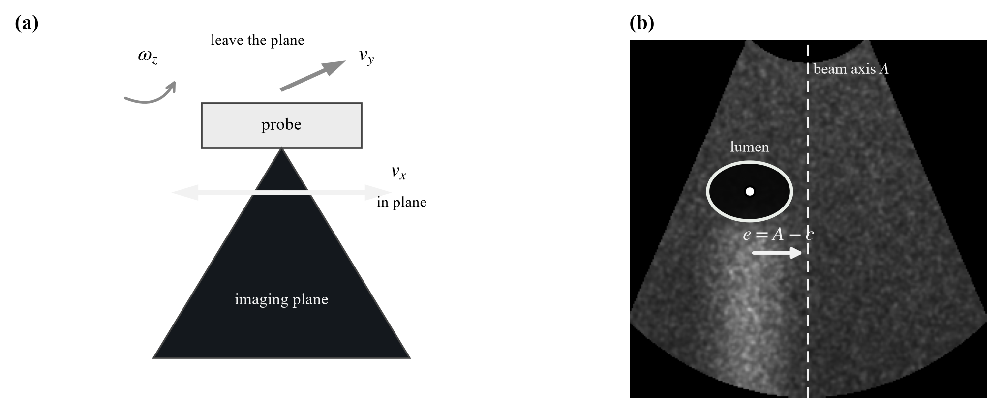
Figure 2. (a) Only lateral sliding v_{x} leaves the imaging plane invariant among the plane-preserving axes. (b) The lateral displacement on one B-mode frame: A is the beam axis, c the lumen centroid, e = A − c.

III. Results
In the distended-bladder working domain Dice reaches 0.882 / 0.892 (val / test). Q is defined on [0, 1] but attains only [0.14, 0.78] and, against a frame-to-frame jitter of 0.0095, separates 47 distinguishable states within its central operating range (Table 1). On 1,936 laterally translated held-out frames the discrete action state is classified at 85.2% (0.10% direction error) and the continuous displacement at slope 0.993 (median 3.15 px); wrong directions occur only near the axis and follow the Gaussian tail Φ(−|e|/σ), licensing the derived 8.1 px hold deadband. Quantising magnitude into graded classes lowers accuracy to 76.5% and 70.7%, so displacement is kept continuous.
Table 1. Main quantitative results on the held-out and laterally translated frames.
Metric | Value
Segmentation Dice, working domain (val / test) | 0.882 / 0.892
Attained Q range (width; central 80%) | 0.64; 0.45
Distinguishable states (full; central 80%) | 67; 47
Action-state accuracy (3 states); direction error | 85.2%; 0.10%
Displacement estimate (slope; median error) | 0.993; 3.15 px
Graded-magnitude accuracy (5; 7 states) | 76.5%; 70.7%

IV. Conclusion
An explainable, quality-aware action-token layer bridges bladder ultrasound segmentation and structured downstream action handling, its hold and check-filling states providing an uncertainty deadband and a physics-based gate that a downstream system can interpret deterministically. The study validates image-to-token generation, not closed-loop control or clinical deployment; re-estimating the constants on intraoperative suprapubic HoLEP imaging and evaluating downstream integration remain future work.
References
1. T. Jang, H.-J. Kong, C. Baek, J. Kim, M. S. Choo, S.-J. Oh. Effect of Self-Training Using Virtual Reality Head-Mounted Display Simulator on the Acquisition of Holmium Laser Enucleation of the Prostate Surgical Skills. International Neurourology Journal 2024;28(2):138–146.
2. O. Ronneberger, P. Fischer, T. Brox. U-Net: Convolutional Networks for Biomedical Image Segmentation. In: MICCAI 2015, LNCS 9351, Springer, 2015, pp. 234–241.
3. M. Saini, Y. Jiang, T. Gangopadhyay, D. P. Rosen, A. Alizad, M. Fatemi. BWS-Net: An Optimal Deep Learning Architecture for the Anterior Bladder Wall Segmentation using Ultrasound Imaging. IEEE J. Biomed. Health Inform. 2026. doi:10.1109/JBHI.2026.3675965.
4. Z. Song, M. Asiedu, S. Wang, et al. Memory-efficient low-compute segmentation algorithms for bladder-monitoring smart ultrasound devices. Scientific Reports 2023;13:16450.
5. H.-L. Hsu, M. Zahiri, G. Y. Li, et al. Active guidance in ultrasound bladder scanning using reinforcement learning. Scientific Reports 2026;16:5273.
6. D. Solís-Martín, J. A. Sainz, J. Galán-Páez, J. Borrego-Díaz, J. A. García-Mejido. PFUS1: Premier pelvic floor ultrasound segmentation dataset. Data in Brief 2026;64:112346.
7. J. A. García-Mejido, D. Solís-Martín, M. Martín-Morán, et al. Applicability of deep learning to dynamically identify the different organs of the pelvic floor in the midsagittal plane. Int. Urogynecol. J. 2024;35(12):2285–2293.
8. Trinkler, Dietrich. Ultrasound of the Urinary Bladder. In: EFSUMB Course Book, European Federation of Societies for Ultrasound in Medicine and Biology, 2019.
[TO BE COMPLETED] HoLEP-morcellation, visual-servoing and IQA citations to be added before submission.

